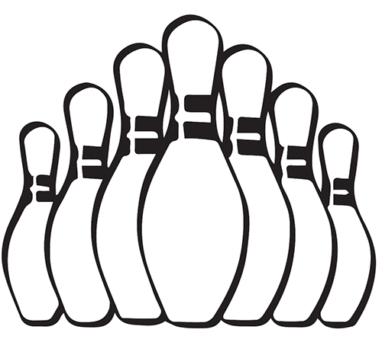
Barry and District Ladies’ Skittle League
Pairs Competition
£1.00 Per Player

To be included in the Pairs Competition entry forms must be received by 6th November.
Entries after this date will not be eligible for the Competition.
If you are unable to attend the meeting please could you email this form to barryanddistrictladiesskittles@gmail.com

Team Name: ……………………………………………

Pair 1 Names
Pair 2 Names
Pair 3 Names
Pair 4 Names
Pair 5 Names

